Magic Squares

Definition: An n x n square grid (where n is the number of cells on each side) filled with distinct positive integers in the range 1,2,..., n² such that each cell contains a different integer and the sum of the integers in each row, column and diagonal is equal.

The sum is called the magic constant/magic sum of the square and is denoted by “M”.
A square grid with n cells on each side is said to have order n.
The constant is dependent on the order. So..
M= n(n²+1)/2
Order (n) | Magic Sum (M)
3 | 15
4 | 34
5 | 65
6 | 111

Magic Square Facts:
- Square of order 1 is trivial. not counted as a magic square but is one by definition.
- Magic square of order 2 cannot be done !
- Any magic square can be rotated and/or reflected to produce 8 distinct trivial squares. However, they are all equivalent and make what is called an equivalent class.
- Number of nontrivial magic squares of a given order:
1 (3x3)
880 (4x4)
275,305,224 (5x5)
About 1.8 x 10¹⁹ (6x6)
- Squares can have negative integers, but they are just variations of a normal magic square by adding or multiplying a negative integer to every positive integer in the original square.
- Different types of magic square: numbers, letters, geometric- 2D and 3D
- Also have semi magic squares that have the same sum in the rows and columns only

Development of Magic Squares
China (650 BC)
Magic squares were thought to have magical or mythical significance and appeared frequently in art.
Lo Shu Square
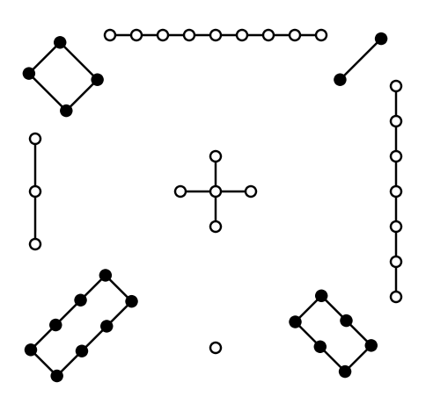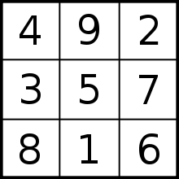
In this case, M=15; Every magic square is some variation of this one.

Formula to construct a 3x3:
c − b | c + (a + b) | c − a
c − (a − b) | c | c + (a − b)
c + a | c − (a + b) | c + b
0<a<b<c and b$≠$2a

Have now been taken to the next level by using extra or different constraints such as, multiplying instead of adding cells, using alternate shapes or more than two dimensions, replacing numbers with shapes and addition with geometric operations.

For example, we have Geomagic Squares in 2D

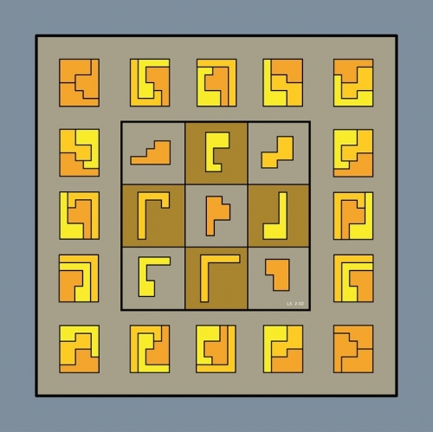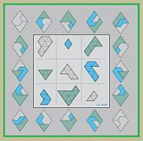

Geomagic Square in 3D
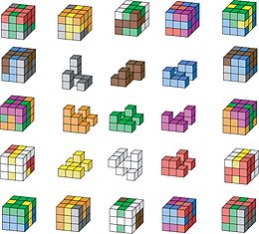

Persia and Arabia (7th century)
The first evidence of magic squares of order 5 and 6.
Example:
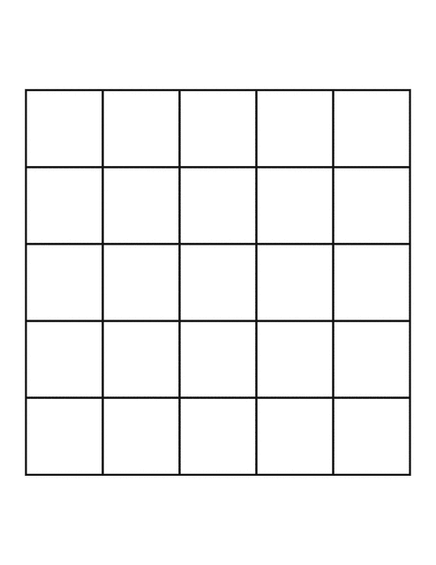

India
Created the most perfect magic square that has 2 additional properties
- Each 2x2 sub square adds to 2s where s= n² +1
- All pairs of integers along main diagonal sum to s.
7 | 12 | 1 | 14
2 | 13 | 8 | 11
16 | 3 | 10 | 5
9 | 6 | 15 | 4

Srinivasa Ramanujan's magic square
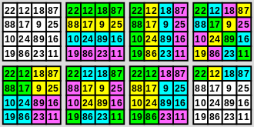
M = 139. First row is birth date.

References
Richardson. (2017). Non-Normal Magic Squares. Retrieved April 26, 2017, from
http://www.math.wichita.edu/~richardson/mathematics/magic%20squares/notnormalmagicsquare.html
Sallows, L. (2011). Geometric Magic Squares. The Mathematical Intelligencer, 33(4),
25-31. doi:10.1007/s00283-011-9229-0
Weisstein, Eric W. "Alphamagic Square." From MathWorld--A Wolfram Web Resource.
http://mathworld.wolfram.com/AlphamagicSquare.html
Wikipedia. (2017). Magic square. Retrieved April 26, 2017, from
https://en.wikipedia.org/wiki/Magic_square

