Fibonacci Numbers and the Golden Ratio

The Fibonacci sequence is a series of numbers where the current number is a combination of the two before it. Therefore, the formula for to find each fibonacci number for n$≥$2:
F_{n} = F_{n-2} + F_{n-1}
The sequence follows as 1,1, 2, 3, 5, 8, 13, 21, 34, etc.

if a Fibonacci number is divided by its immediate predecessor in the sequence, the quotient approximates:
$\frac{Fn}{Fn-1}$= 1.618
This is the phi $(ϕ)$Also called: Golden Ratio, Divine Proportion, or Golden Section

Has been used in sculpture since 500 BC in ancient Greece and has been found naturally occurring in nature, photography, logo designs, and many other places.
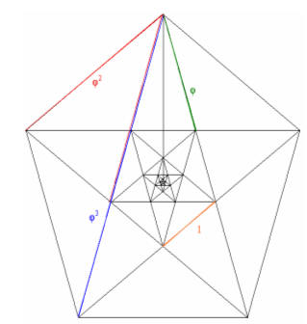
Euclid proved that the diagonals of the regular pentagon cut each other in the golden ratio.
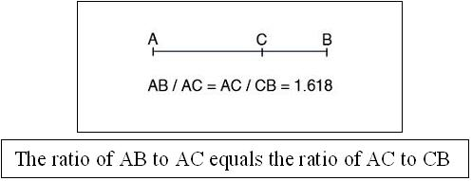
How to make the Golden Spiral
- We are going to start by making a square. So turn off the axes and the grid lines by right clicking and using the drop down menu to unclick these features.

- Next make a line segment using the tool from the toolbar. Now use the perpendicular tool to create a perpendicular line at point B. Click perpendicular line in the toolbar, then click the line segment and the point you are making the line through.

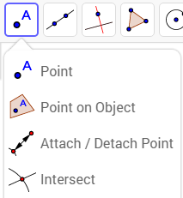
- Next click circle with center through point in the toolbar. Click point B as your center and then point A as your radius. You have just copied the length of a line. We must first find the intersection of the circle and the perpendicular line we created using the intersection button in the toolbar. Find the intersection and create a point C.

- Use the parallel line tool from the toolbar; click the line segment AB and then click point C. Use the perpendicular line tool again but this time for point A. Click the segment AB and then point A. Find the intersection of this new perpendicular line and the parallel line using the intersection tool.

- Use the polygon tool from the toolbar; Click the points ABCD and the click point A again to close the shape. You can now hide all the previous lines and points by clicking the circles next to each construct on the left menu.

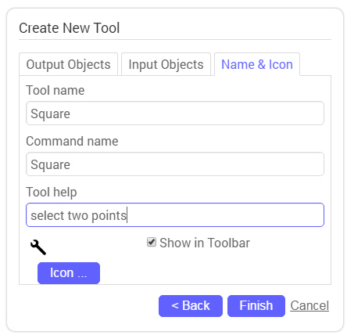
- If you right click anywhere on the object you get a drop down menu that has object properties at the bottom. Click this option, once open go to the color tab, click black and change the opacity to 0.

- We are going to save this square as a shortcut to use later. In the top menu, click tools and then create new tool.
- This should now be in your toolbar

- Select file from the menu bar and click “new”. No need to save your shape, the tool should remain in your toolbar. You can now turn on your grid lines and turn off your axes.
- With this tool we can now create squares by only selecting two points. Click the tool from the toolbar and create points A and B by clicking the bottom corners (left to right) of any one block of the grid. This will form a square. Now click the top two corners (left to right) to create points C and D.
- This is where Knowing the Fibonacci sequence comes in. We know it goes
[ 1,1,2,3,5,8,13,21..]
- So the next square needs to be 2 boxes to the right. Click point B then count 2 boxes to the right and create point E.
- Click the top left corner (above C) of the new shape and the top right corner (2 boxes above E). Continue in a spiral shape that goes counter clockwise.
- Count 5 boxes to the left of point A. Create point H and then select point A.
- Count down 8 boxes from point H and reate point I. Count to the right 8 spaces to create point J.
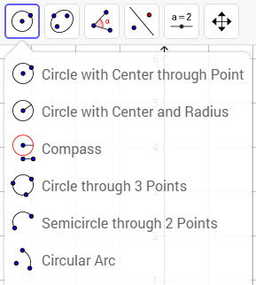
- Click point J, count to the right 13 boxes and create K. This is the framework to create the spiral.
- We are going to use the circular arc to click points in this specific order (D, Unlabeled corner of box will turn into L after you click it, C) (D,C,B) (L,B,G) (F,G, Top left corner of square will turn to M) (A,M,H) (E,H,J)(top left corner of box will turn to N, J, O)
- You can now turn off all points and labels. Select All conic lines and change their color to see your golden spiral.

Should look like this:
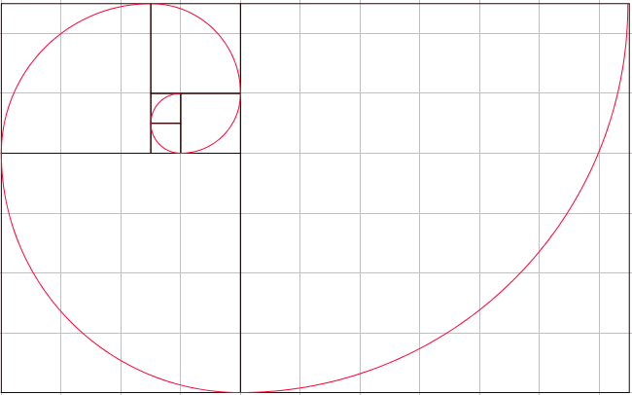

Interesting objects with the golden ratio
